Control 2.0
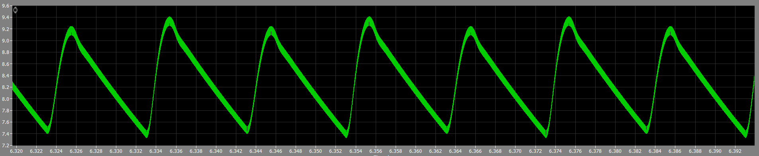
To design a control circuit, the choice is between type 1,2 or 3. The main purpose of control circuit is to maintain the 8V output voltage, reduce output voltage ripple to <0.2V and the 100Hz ripple caused by the rectifier shown in Figure(--).

Even though type 1 control circuit is easy having only a single capacitor and resistor. It does not meet our requirement—0.2V output ripple when feeding alternating current as input whilst this project relies on the control circuit to remove it. Thus, having type 3 control circuit is the go-to choice. The transfer function for type 3 control circuit is given as:
$$\begin{aligned}G_{c}\left(s\right)=\frac{A}{s}\frac{{\left(1+\frac{s}{\frac{ω_{c}}{\sqrt{k}}}\right)}^{2}}{{\left(1+\frac{s}{\sqrt{k}ω_{c}}\right)}^{2}} \#\left(1\right)\end{aligned}$$
Where:
$k$ is Venable’s k-factor
An integrator is inside the equation needed for the steady state accuracy. Two zeros are placed at a frequency below the crossover frequency ($ω_{c}$) and two poles at a frequency above crossover frequency. The zeros provide a phase-lead, which helps reduce the phase lag of the control loop at the crossover frequency. The poles are there as we never realise a transfer function with more zero than poles which gives a phase lag again, but there are above the crossover frequency to minimize the effect on stability. As for now, this paper is discussing on implementation Venable’s design.

Crossover Frequency, $ω_{c}$
Crossover frequency ($ω_{c}$) is a value above the resonant frequency ($ω_{resonant}$). It could be chosen between 2 till 10 as the multiplier. For this project, the team chose 4 as the multiplier due to making it too low won’t get enough loop gain at 100Hz and too high causes instability issue by high frequency noise which affect the control loop. Thus, making the equation below.
$$\begin{aligned}ω_{c}=4×ω_{resonant}\#\left(2\right)\end{aligned}$$
While,
$$\begin{aligned}ω_{resonant}=\frac{1}{\sqrt{LC}}\#\left(3\right)\end{aligned}$$
From the previous report, $L$ = 49$μH$ and $C=940μF$. Substitute into the equation we get:
$$ω_{c}=\frac{4}{\sqrt{49μ×940μ}}$$
$$ω_{c}=18637.94$$
LC filter Transfer Function, $G_{f}\left(s\right)$
The LC filter transfer function ($G_{f}\left(s\right)$) is the mathematical baseline for the control circuit. Without it, the compensator in the control circuit would have to guess the output. This transfer function is also essential for finding the gain and phase boost for later. More importantly, this enables us to find the transfer function for the control circuit $G_{c}\left(s\right)$ later.
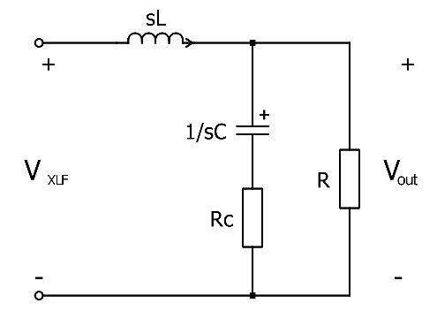
To get the transfer function, consider the circuit below.
To get the transfer function,
$$G_{f}\left(s\right)=\frac{V_{out}\left(s\right)}{V_{XLF}\left(s\right)}$$
$$G_{f}\left(s\right)=\left(\frac{R}{R+R_{C}}\right)\frac{1+sR_{C}C}{s^{2}LC+s\left(\frac{L+CRR_{C}}{R+R_{c}} \right)+\frac{R}{R+R_{c}}}$$

For any sensible design and operating condition $R≫R_{c}$, the equation can be simplified as:
$$G_{f}\left(s\right)=\frac{1+sR_{c}C}{s^{2}LC+s\left(\frac{L}{R}+CR_{c}\right)+1}$$
By substituting the $L=49μ,R_{c}=0.1,C=940μ$ and $R=5$.
$$G_{f}\left(s\right)=\frac{1+s\left(0.1\right)\left(940μ\right)}{s^{2}\left(49μ\right)\left(940μ\right)+s\left(\frac{49μ}{5}+\left(940μ\right)\left(0.1\right)\right)+1}$$
$$G_{f}\left(s\right)=\frac{1+\left(9.4×{10}^{-5}\right)s}{\left(4.61×{10}^{-8}\right)s^{2}+\left(1.038×{10}^{-4}\right)s+1}$$
To get the phase margin and magnitude at crossover frequency ($ω_{c}$)of the transfer function $G_{f}\left(s\right)$, Replace $s$ with $jω_{c}$.
To find magnitude,
$$\left|G_{f}\left(jω_{c}\right)\right|=\frac{\left|1+\left(jω_{c}\right)\left(9.4×{10}^{-5}\right)\right|}{|\left(4.61×{10}^{-8}\right){\left(jω_{c}\right)}^{2}+\left(1.038×{10}^{-4}\right)(jω_{c})+1|}$$
$$\left|G_{f}\left(jω_{c}\right)\right|=\frac{\left|1+j1.752\right|}{|-15.014+j1.935|}$$
$$\left|G_{f}\left(jω_{c}\right)\right|=0.1332$$
To find phase margin,
$$∠G_{f}\left(jω_{c}\right)=\tan^{-1}\left(\frac{1.752}{1}\right)-\tan^{-1}\left(\frac{1.935}{-15.014}\right)+180°$$
The second part of the calculation needed to add another $180°$ due to the quadrant error. This is due to the $-15.014+j1.935$ sits in quadrant II while our calculator is limited to $-90°$ to $+90°$. Thus, can’t directly input inside calculator.
$$∠G_{f}\left(jω_{c}\right)=247.67° or-112.373°$$

Phase Boost, $B$ and k-factor, $k$
The phase boost, $B$ is required to know how much phase boost is needed for the control circuit. The desired phase margin ($PM$) is $60°$. The equation is given by:
$$Phase Margin, PM=180-90+∠G_{f}\left(jω_{c}\right)+B$$
$$B=PM-180+90-∠G_{f}\left(jω_{c}\right)$$
$$B=60-180+90-\left(-112.373\right)$$
$$B=82.373°$$
k-factor is needed for calculation. By using Venable’s formula,
$$k={\left[\tan\left(\frac{B}{4}+45\right)\right]}^{2}$$
$$k={\left[\tan\left(\frac{82.373}{4}+45\right)\right]}^{2}$$
$$k=4.856$$

A Value of amplifier circuit and pwm circuit, $K_{misc}$
The value for $K_{misc}$ is essential as this is adding the pwm with the potential divider into the equation. The given equation is:
$$K_{misc}=αK_{pwm}V_{S0}n$$
$α$ is the potential divider value. Any value less than 5V can be chosen as the reference voltage since the max voltage accepted by the operational amplifier is 5V and supply voltage. Thus, this project chose 3V as the reference voltage. Giving the equations are:
$$α=\frac{V_{ref}}{V_{out}}$$
$$α=\frac{3}{8} or 0.375$$
$K_{pwm}$ given equation is:
$$K_{pwm}=\frac{d_{max}}{V_{b}-V_{a}}$$
Where:
$d_{max}$ is the maximum duty cycle output from the pwm chip.
$V_{b}$ is the input threshold voltage for maximum duty cycle.
$V_{a}$ is the input threshold voltage for minimum duty cycle.

$$∴K_{pwm}=\frac{0.45}{3.5-1}$$
$$K_{pwm}=0.18$$
$V_{S0}$ is the maximum input voltage—39.74V. This value is able to obtain from simulation or manually calculate which I wont fucking touch ahahahahahaaha.
$n$ is the turn ratio of the transformer. Since the transformer being used is a 1 to 1 transformer, the $n$ is equal to 1.
By substituting everything into the equation:
$$K_{misc}=\left(0.375\right)\left(0.18\right)\left(39.74\right)\left(1\right)$$
$$K_{misc}=2.6824$$

Gain Required, $G$
The Gain required by the controller can be calculated with the following equation.
$$G=\frac{1}{K_{misc}\left|G_{f}\left(jω_{c}\right)\right|}$$
This would provide us with some ideas and the essential to calculate the component value.
$$G=\frac{1}{\left(2.6824\right)\left(0.1332\right)}$$
$$G=2.799$$
Integrator Gain, $A$
With the Gain obtained from the previous section, the integrator gain can get by this equation.
$$A=\frac{Gω_{c}}{k}$$
$$A=\frac{\left(2.799\right)\left(18637.94\right)}{4.856}$$
$$A=10742.91$$

Transfer Function for controller, $G_{c}\left(s\right)$
With the obtained $A$ value, the transfer function of the controller loop is possible to obtain with the equation below.
$$G_{c}\left(s\right)=\frac{A}{s}\frac{\left(1+\frac{s}{ω_{z1}}\right)\left(1+\frac{s}{ω_{z2}}\right)}{\left(1+\frac{s}{ω_{p1}}\right)\left(1+\frac{s}{ω_{p2}}\right)}$$
While
$$ω_{z1}=ω_{z2}=\frac{ω_{c}}{\sqrt{k}}=\frac{18637.94}{\sqrt{4.856}}=8457.823$$

And
$$ω_{p1}=ω_{p2}=\sqrt{k}ω_{c}=\left(18637.94\right)\left(\sqrt{4.856}\right)=41071.19$$
Giving
$$G_{c}\left(s\right)=\frac{10742.91}{s}\frac{\left(1+\frac{s}{8457.823}\right)\left(1+\frac{s}{8457.823}\right)}{\left(1+\frac{s}{41071.19}\right)\left(1+\frac{s}{41071.19}\right)}$$
$$G_{c}\left(s\right)=\frac{1.812×{10}^{13}s^{2}+3.065×{10}^{17}s+1.296×{10}^{21}}{7.153×{10}^{3}s^{3}+5.876×{10}^{12}s^{2}+1.207×{10}^{17}s}$$

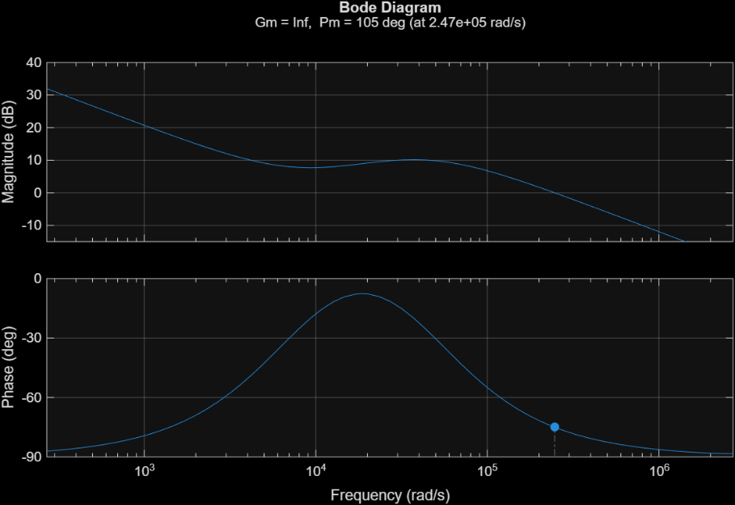
With the obtained $G_{c}\left(s\right)$, it is possible to plot the bode diagram which is shown in figure below.

Verifying the control
To verify our control circuit, the open loop transfer function graph and the closed loop transfer function graph need to be found.
The open loop Bode plot helps to prove the stability of the control system and the ability the reject the rectifier ripple. The open loop transfer function is given by:
$$G_{loop}\left(s\right)=G_{c}\left(s\right)×G_{f}\left(s\right)×K_{misc}$$
By substituting in the values, we got:
$$∴G_{loop}\left(s\right)=\frac{4.563×{10}^{9}s^{3}+1.257×{10}^{14}s^{2}+1.147×{10}^{18}s+3.472×{10}^{21}}{3.295s^{5}+2.781×{10}^{5}s^{4}+6.239×{10}^{9}s^{3}+1.840×{10}^{13}s^{2}+1.207×{10}^{17}s}$$

By plotting the graph using MATLab,
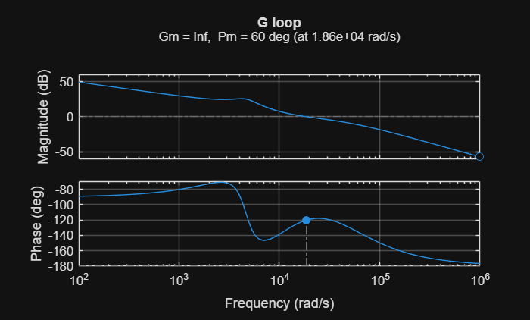
Figure (): the open loop phase and magnitude against frequency graph
As shown in the figure (), the gain margin is shown infinity. Which means the phase would not reach to $-180°$ mark when the gain is above 0dB, which proves that the system is stable. Another thing to take note of is the phase margin, the graph shows that the phase margin is $60°$ at the crossover frequency which is the targeted phase margin. This ensures that the system is highly stable and won’t oscillate and capable of providing sufficient transient response when load changes.
The close loop Bode plot enables us to see the system response with reference to outside perspective. The given formula for close loop transfer function is:
$$G_{close-loop}\left(s\right)=\frac{G_{loop}\left(s\right)}{1+G_{loop}\left(s\right)}$$

By substituting $G_{loop}\left(s\right)$ into $G_{close-loop}\left(s\right)$:
$$G_{close-loop}\left(s\right)=$$
$$\frac{1.50×{10}^{10}s^{8}+1.68×{10}^{15}s^{7}+6.72×{10}^{19}s^{6}+1.20×{10}^{24}s^{5}+1.10×{10}^{28}s^{4}+5.80×{10}^{31}s^{3}+2.02×{10}^{35}s^{2}+4.19×{10}^{38}s}{10.86s^{10}+1.83×{10}^{6}s^{9}+1.34×{10}^{11}s^{8}+5.27×{10}^{15}s^{7}+1.17×{10}^{20}s^{6}+1.50×{10}^{24}s^{5}+1.28×{10}^{23}s^{4}+6.34×{10}^{31}s^{3}+2.17×{10}^{35}s^{2}+4.19×{10}^{38}s}$$

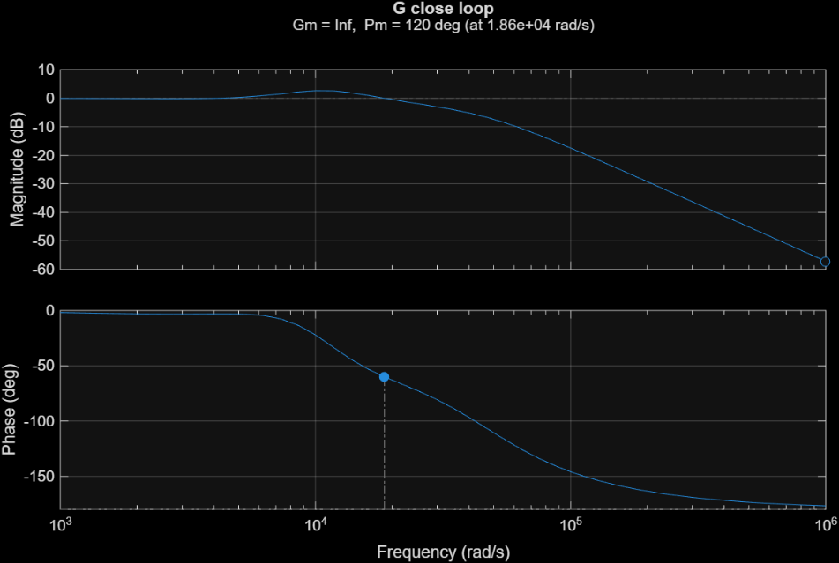
Having $G_{close-loop}\left(s\right)$, the plot margin can obtain as figure shown.

Figure (): The close loop bode plot with phase and magnitude
From figure (), it shows the magnitude at low frequencies is 0dB which satisfy our requirement. This shows that the system perfectly tracks the output voltage with 0 steady state error. Continue at the magnitude graph, it shows that the gain drops at frequency which is the desired output. The control system acts like a low-pass filter, which helps ignoring switching noise and doesn’t destabilize the feedback loop.

The calculation for components for $Z_{1} and Z_{2}$
For a type 3 controller, there’s a $Z_{1}$ and $Z_{2}$ component which shown in figure ().
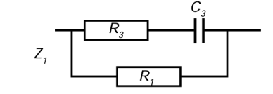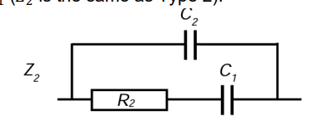
Figure (): the component for $Z_{1}$ Figure (): the component for $Z_{2}$

To calculate components in $Z_{1}$, the equation given to these are:
$$R_{3}=\frac{R_{1}}{k-1}$$
$$C_{3}=\frac{1}{R_{3}ω_{c}\sqrt{k}}$$
Assume $R_{1}=10kΩ$,
$$R_{3}=\frac{{10×10}^{3}}{4.856-1}$$
$$R_{3}=2.593kΩ$$
$$C_{3}=\frac{1}{\left(2.593×{10}^{3}\right)\left(18637.94\right)\left(\sqrt{4.856}\right)}$$
$$C_{3}=9.389nF$$
To calculate components in $Z_{2}$, the equation given to these are:
$$C_{2}=\frac{1}{R_{1}ω_{c}G}$$
$$C_{1}=C_{2}×\left(k-1\right)$$
$$R_{2}=\frac{\sqrt{k}}{ω_{c}C_{1}}$$
By substituting the obtained value,
$$C_{2}=\frac{1}{\left(10×{10}^{3}\right)\left(18637.94\right)\left(2.799\right)}$$
$$C_{2}=1.916nF$$
$$C_{1}=\left(1.916×{10}^{-9}\right)×\left(4.856-1\right)$$
$$C_{1}=7.388nF$$
$$R_{2}=\frac{\sqrt{4.856} }{\left(18637.94\right)\left(7.388×{10}^{-9}\right)}$$
$$R_{2}=16.00kΩ$$
By putting the values in, the obtain circuit will be like this, 